REAL-TIME SPEECH EMOTION RECOGNITION USING DEEP 1D-CNN NETWORKS

ABSTRACT
Speech Emotion Recognition (SER) is an important research area in Human-Computer Interaction (HCI). This project presents an intelligent system capable of identifying five human emotions—Angry, Fearful, Happy, Neutral, and Sad—from speech recordings.
The system utilizes the RAVDESS dataset and extracts a comprehensive 44-dimensional feature vector from each audio sample. The extracted features include Mel-Frequency Cepstral Coefficients (MFCCs), Pitch, Root Mean Square (RMS) Energy, Zero Crossing Rate (ZCR), and Spectral Centroid.
A Deep One-Dimensional Convolutional Neural Network (1D-CNN) integrated with Batch Normalization and Dropout regularization is designed for emotion classification. The trained model achieved an overall classification accuracy of 48% on the test dataset. A real-time web application was developed using the Gradio framework, enabling users to record speech and obtain instant emotion predictions.
Keywords: Speech Emotion Recognition, Deep Learning, CNN, MFCC, Audio Signal Processing, Human-Computer Interaction.

SYSTEM ARCHITECTURE AND METHODOLOGY
The proposed Speech Emotion Recognition system consists of five major processing stages:
Audio Input (.wav)
↓
Audio Preprocessing
↓
Feature Extraction
↓
Deep Learning Classification
↓
Emotion Prediction

Processing Pipeline
Audio Track (.wav)
↓
Audio Loading and Resampling (22.05 kHz)
↓
Feature Extraction
- MFCC (40)
- Pitch (1)
- RMS Energy (1)
- Zero Crossing Rate (1)
- Spectral Centroid (1)
Total Features = 44
↓
Deep 1D-CNN Network
↓
Softmax Classification Layer
↓
Predicted Emotion Label

FEATURE ENGINEERING
To improve emotional representation within speech signals, a 44-dimensional feature vector was constructed using the Librosa audio analysis library.

1. Mel-Frequency Cepstral Coefficients (MFCC)
Forty MFCC coefficients were extracted from each speech signal. These coefficients capture perceptually relevant frequency characteristics and closely resemble human auditory perception.

2. Pitch
Pitch was extracted using the Librosa piptrack algorithm. Different emotions often produce noticeable variations in vocal pitch.

3. RMS Energy
Root Mean Square (RMS) Energy was used to quantify speech intensity. High-energy emotions such as anger generally produce higher RMS values compared to low-energy emotions such as sadness.

4. Frequency Variation Features

Zero Crossing Rate (ZCR)
ZCR measures the rate at which the audio signal changes sign. It provides information about signal sharpness and speech dynamics.

Spectral Centroid
Spectral Centroid indicates the center of mass of the frequency spectrum and represents the perceived brightness of a sound.

Final Feature Vector
MFCC Features = 40
Pitch = 1
Energy = 1
Zero Crossing Rate = 1
Spectral Centroid = 1
Total Features = 44
Dataset Shape = 864 × 44

MODEL ARCHITECTURE
A Deep 1D Convolutional Neural Network (1D-CNN) was developed to learn discriminative patterns from the extracted acoustic features.

Layer Configuration

Layer 1
- Conv1D
- 256 Filters
- Kernel Size = 5
- ReLU Activation

Normalization
- Batch Normalization

Pooling
- MaxPooling1D
- Pool Size = 5

Layer 2
- Conv1D
- 128 Filters
- ReLU Activation

Normalization
- Batch Normalization

Pooling
- MaxPooling1D

Regularization
- Dropout = 0.2

Layer 3
- Conv1D
- 64 Filters
- ReLU Activation

Normalization
- Batch Normalization

Pooling
- MaxPooling1D

Regularization
- Dropout = 0.3

Dense Layer
- Fully Connected Layer
- 512 Neurons
- ReLU Activation

Regularization
- Dropout = 0.4

Output Layer
- Softmax Activation
- Five Emotion Classes

EXPERIMENTAL RESULTS AND EVALUATION

Dataset Split
Training Samples = 691
Testing Samples = 173
Training Ratio = 80%
Testing Ratio = 20%
Number of Epochs = 70

Classification Results
Emotion | Precision | Recall | F1-Score
Angry | 0.73 | 0.80 | 0.76
Fearful | 0.41 | 0.73 | 0.52
Happy | 0.32 | 0.43 | 0.37
Neutral | 0.67 | 0.09 | 0.16
Sad | 1.00 | 0.12 | 0.22

Overall Metrics
- Accuracy = 48%
- Macro Average F1 Score = 0.41
- Weighted Average F1 Score = 0.44

Performance Analysis
The model demonstrated its strongest performance in detecting Angry speech samples, achieving an F1-score of 0.76. The Sad emotion class achieved a precision score of 1.00, indicating that all samples predicted as Sad were correctly classified. However, the low recall value suggests that many actual Sad samples were not detected. This highlights the challenge of distinguishing subtle emotional variations within speech signals.

Confusion Matrix
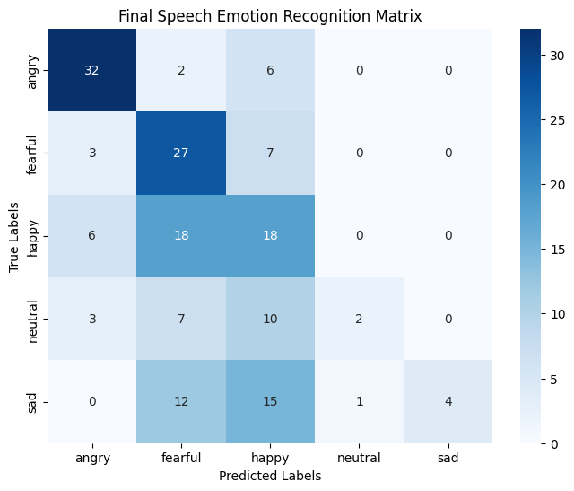

SYSTEM DEPLOYMENT
To enable real-time emotion recognition, the trained model was integrated with the Gradio framework.
The deployed interface provides:
- Browser-based microphone recording
- Audio file upload support
- Real-time feature extraction
- Instant emotion prediction
- Confidence score visualization
Users can record speech directly through the web interface and obtain emotion predictions within seconds.

CONCLUSION AND FUTURE WORK

Conclusion
This project successfully implemented a Speech Emotion Recognition system using a Deep 1D Convolutional Neural Network and acoustic feature engineering techniques. The model was trained on the RAVDESS dataset and evaluated using standard classification metrics. The developed system demonstrates the practical applicability of deep learning for speech-based emotion analysis and provides real-time inference through a Gradio web interface.

Future Scope

Cross-Lingual Emotion Recognition
The system can be extended to support regional languages such as Tamil by training on multilingual emotional speech datasets.

Transformer-Based Architectures
Future research may replace conventional CNN layers with advanced transformer-based models such as Wav2Vec 2.0 to improve temporal feature learning and classification accuracy.

Noise Robustness
Additional preprocessing techniques can be introduced to improve performance under noisy real-world environments.

Larger Datasets
Training on larger and more diverse emotional speech datasets can significantly improve generalization capability and recognition accuracy.

REFERENCES
- RAVDESS Emotional Speech Dataset.
- TensorFlow Documentation.
- Librosa Audio Analysis Library Documentation.
- Scikit-Learn Documentation.
- Research Articles on Speech Emotion Recognition and Deep Learning.

